Последовательное подключение

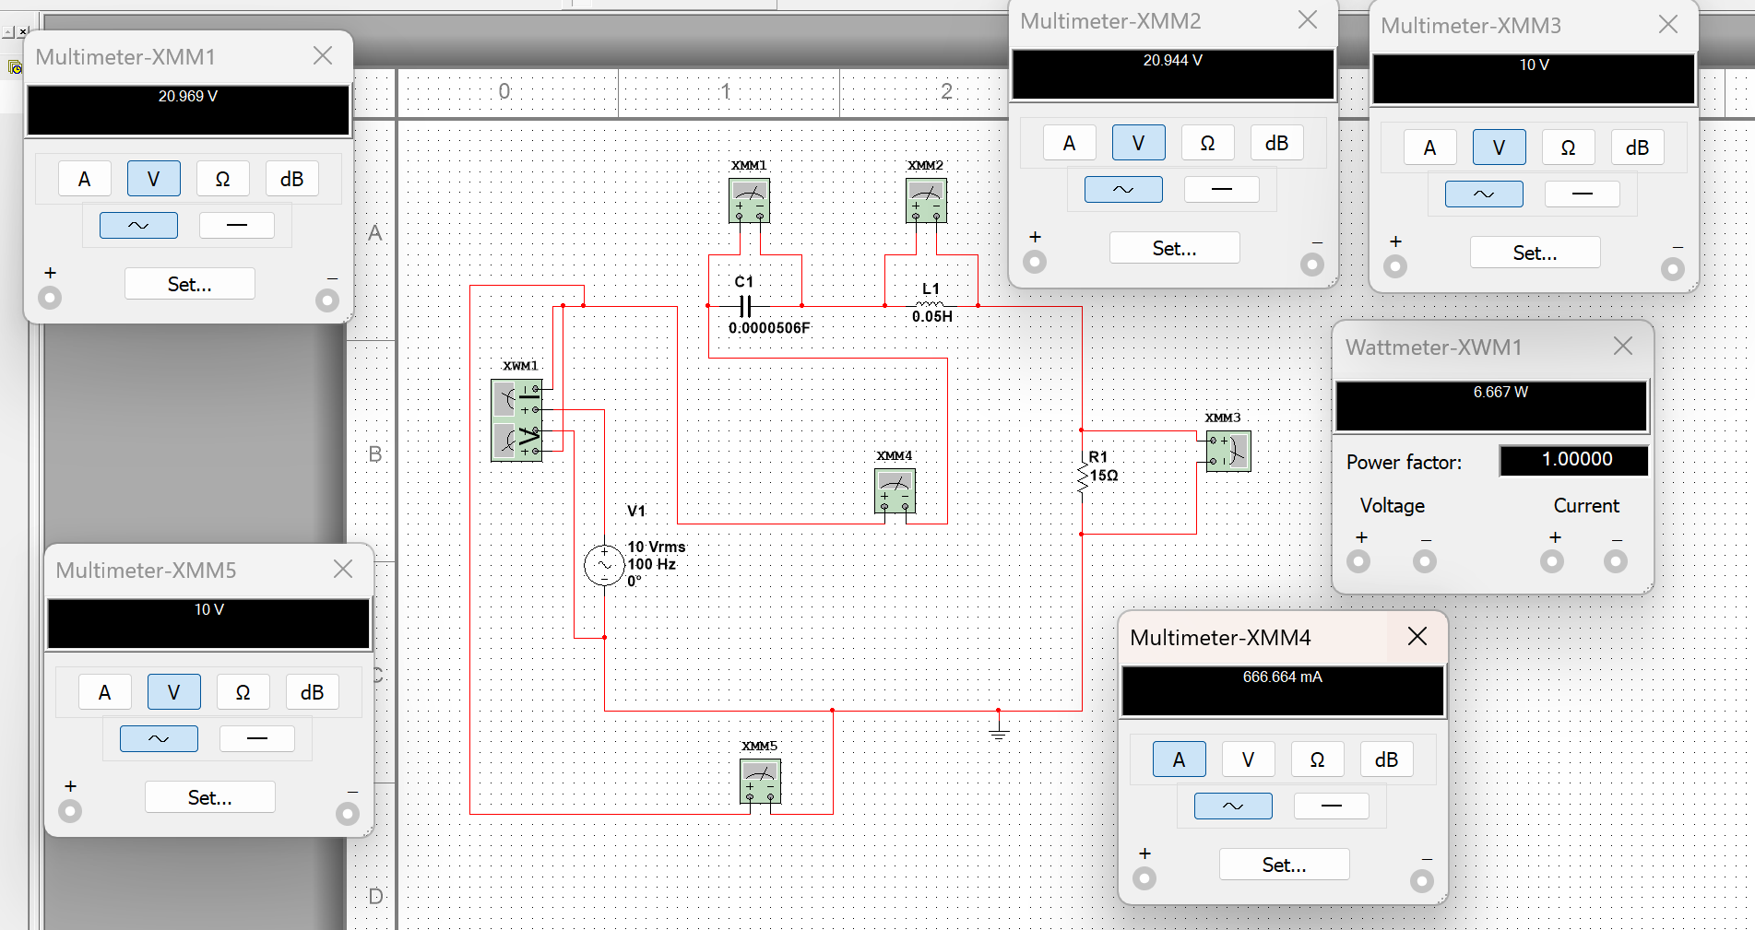

|  |  |  |  |  |  |  |  |  |  |  |  |  |  |  |  |  |  |  |
| --- | --- | --- | --- | --- | --- | --- | --- | --- | --- | --- | --- | --- | --- | --- | --- | --- | --- | --- |
|  | Измерения | | | | | Вычисления | | | | | | | | | | | |  |
| № | U, | I, | P, | Ik | Ic | Ur | Uc | Zk | Xl | R | Xc | X | Ql | Qc | Q | φk | ф | C, |
| 1 | 10 | 666.664 mA | 6.667 | 666.664 mA | 666.664 mA |  |  |  |  |  |  |  |  |  |  |  |  |  |
| 2 | 10 | 461.178 mA | 3.190 | 461.178 mA | 461.178 mA |  |  |  |  |  |  |  |  |  |  |  |  |  |
| 3 | 10 | 460.338 mA | 3.179 | 460.338 mA | 460.338 mA |  |  |  |  |  |  |  |  |  |  |  |  |  |

2) емкость *0.5

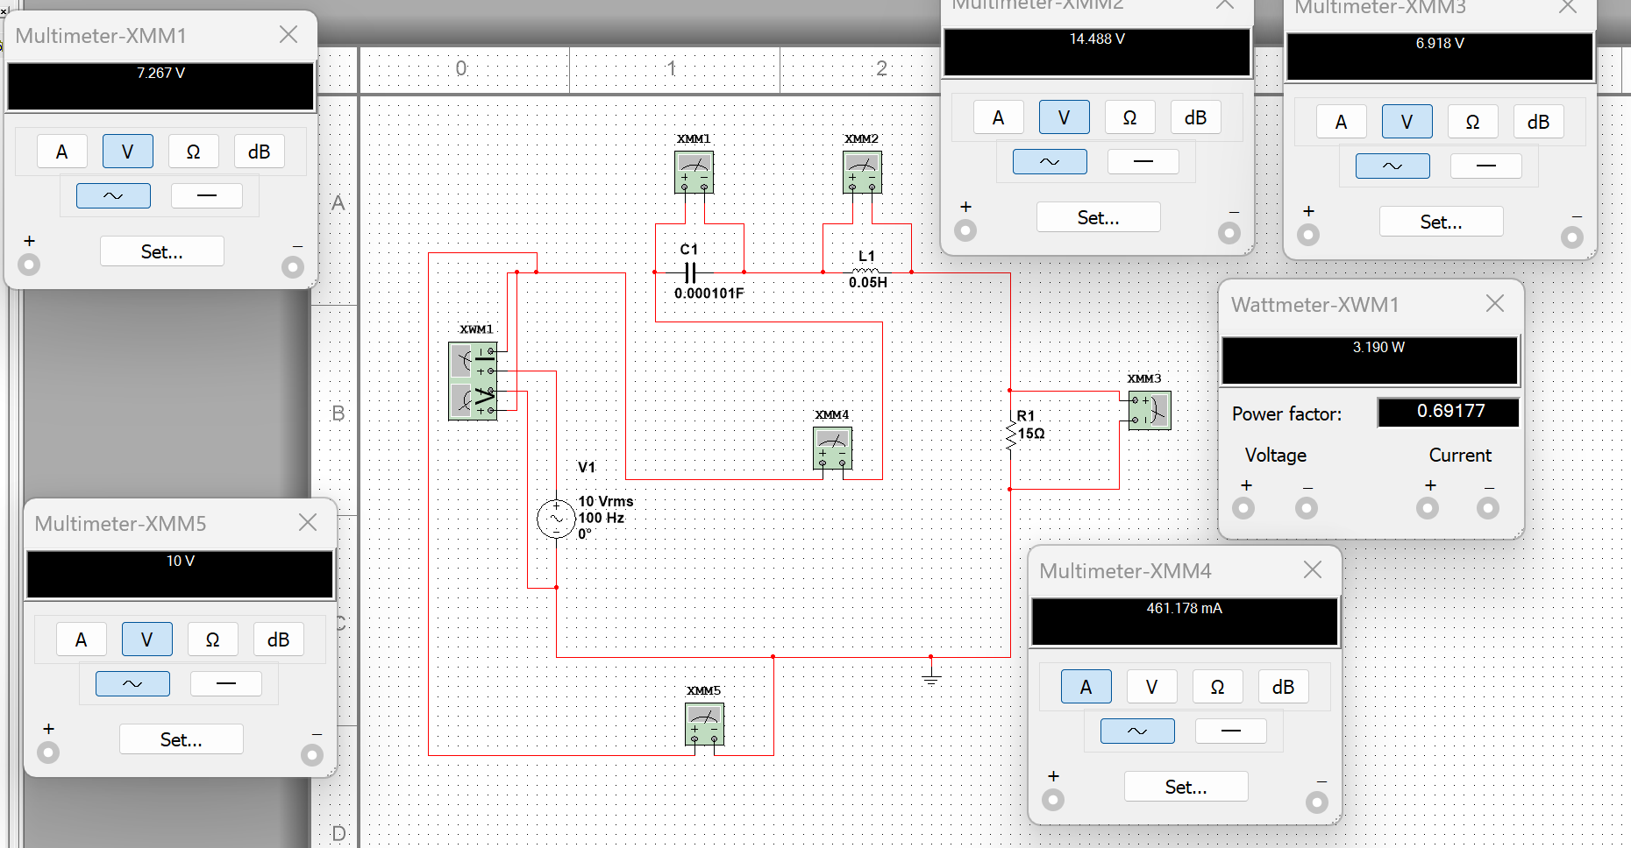

3)емкость*1.5

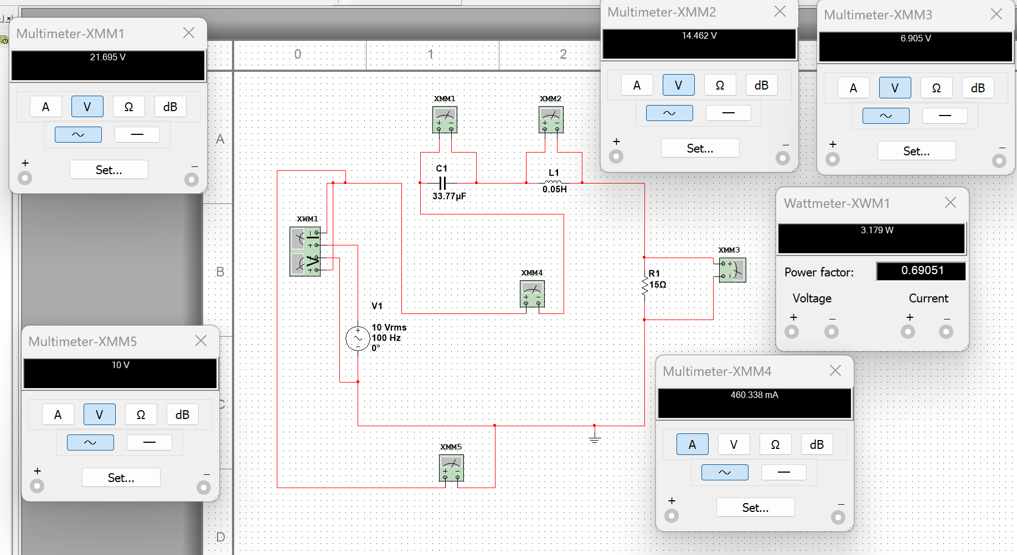

**Phi должен стремится к нулю**

Параллельное подключение

Рассматривается равенство проводимостей -> с=0.00004126

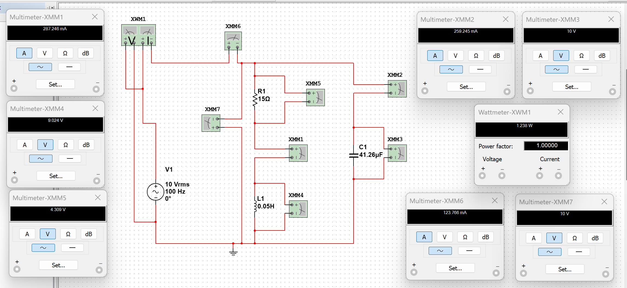

|  |  |  |  |  |  |  |  |  |  |  |  |  |  |  |  |  |  |  |
| --- | --- | --- | --- | --- | --- | --- | --- | --- | --- | --- | --- | --- | --- | --- | --- | --- | --- | --- |
|  | Измерения | | | | | Вычисления | | | | | | | | | | | |  |
| № | U, | I, | P, | Ik | Ic | Ur | Uc | Zk | Xl | R | Xc | X | Ql | Qc | Q | φk | ф | C, |
| 1 | 10 | 123.766 mA | 1.238 | 287.246 mA | 259.245 mA |  |  |  |  |  |  |  |  |  |  |  |  | 41.26 uF |
| 2 | 10 |  |  |  |  |  |  |  |  |  |  |  |  |  |  |  |  | 20.63uF |
| 3 | 10 |  |  |  |  |  |  |  |  |  |  |  |  |  |  |  |  | 61.89uF |

На катушке ток и реактивный, и активный

C=0.5c

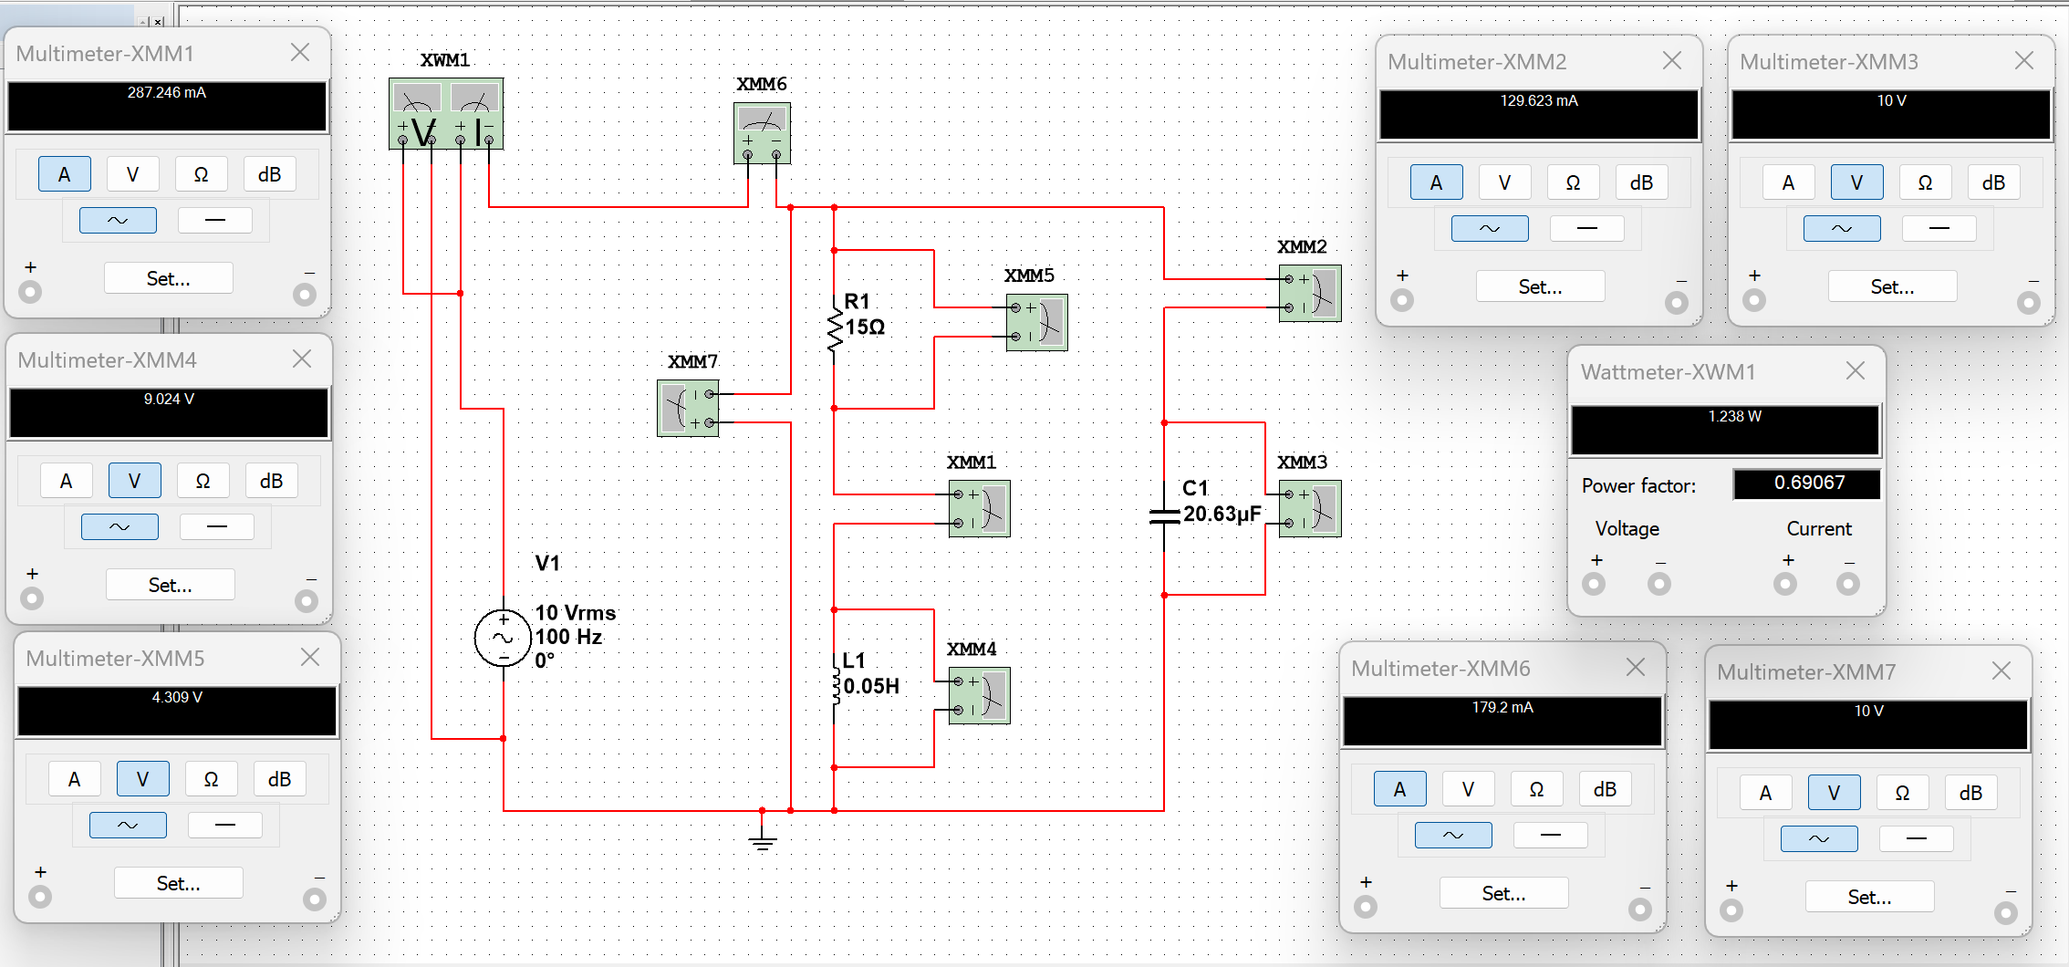

C=1.5c

